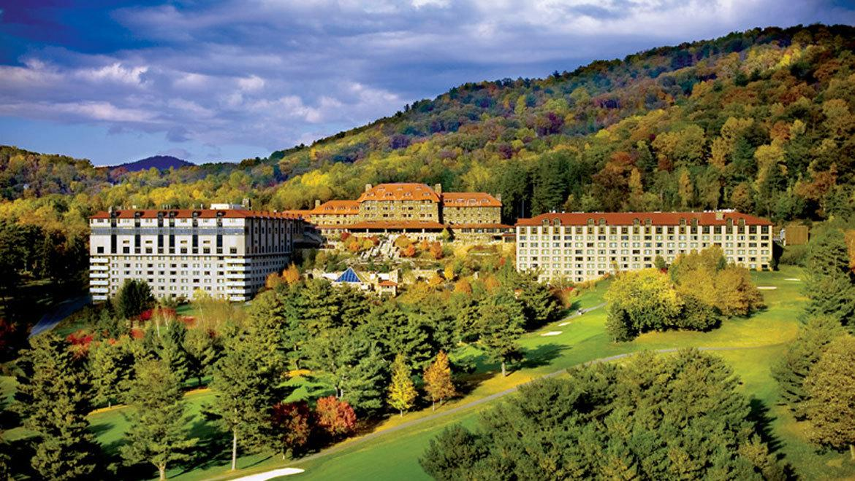  22-24 february 2019  71st Annual Conference  Due to popular demand, we will be returning to the Omni Grove Park Inn, 290 Macon Ave, Asheville, NC for our 71st annual state conference. We hope to see you there for a weekend of fellowship and fun!  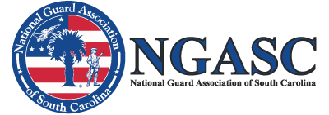 | Friday Night Icebreaker!  Spouse Auxiliary Brunch!  Saturday Night Formal Gala!  Breakout and Business Sessions!  Vendor and Exhibit Booths!  Hospitality Suites!  NGASC  132 Pickens St.  Columbia, SC 29205  803-254-8456  www.ngasc.org  mvick@ngasc.org

